# MongoDB Coding Assessment

## Aarthi. P 25/07/25

**Relations In MongoDB:**

MongoDB is a **NoSQL, document-based database**—it stores data in **JSON-like documents** (BSON), not tables. While it is **schema-less** and doesn't use traditional relational models like SQL databases, you can still represent **relationships** between data in **three main ways**:

1. ****One-to-One (1:1):****

****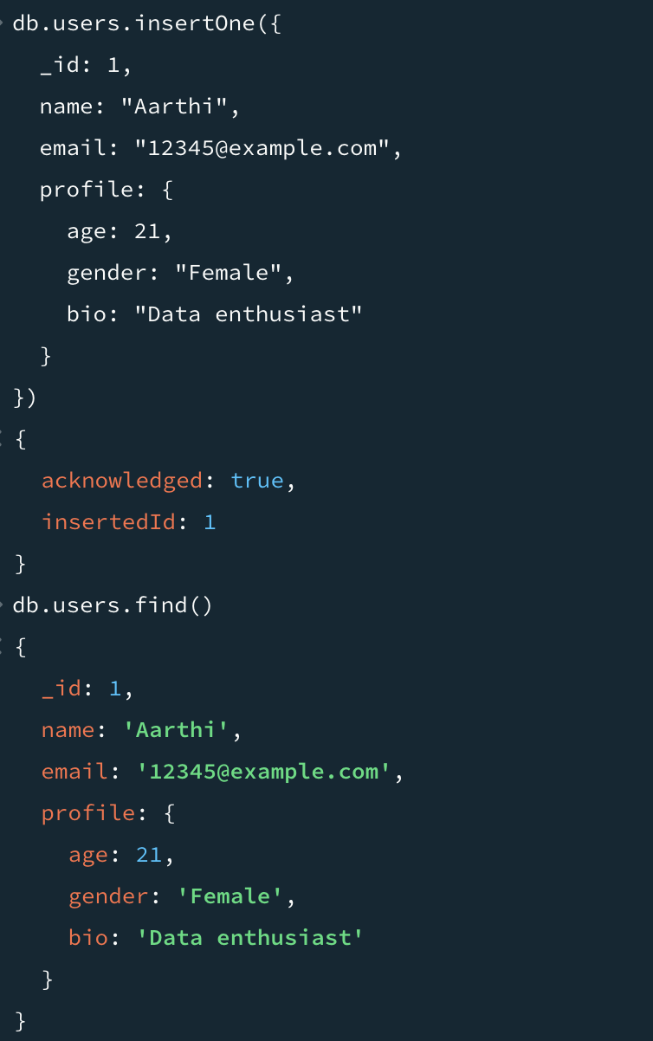****

1. **One-to-Many (1:N):**

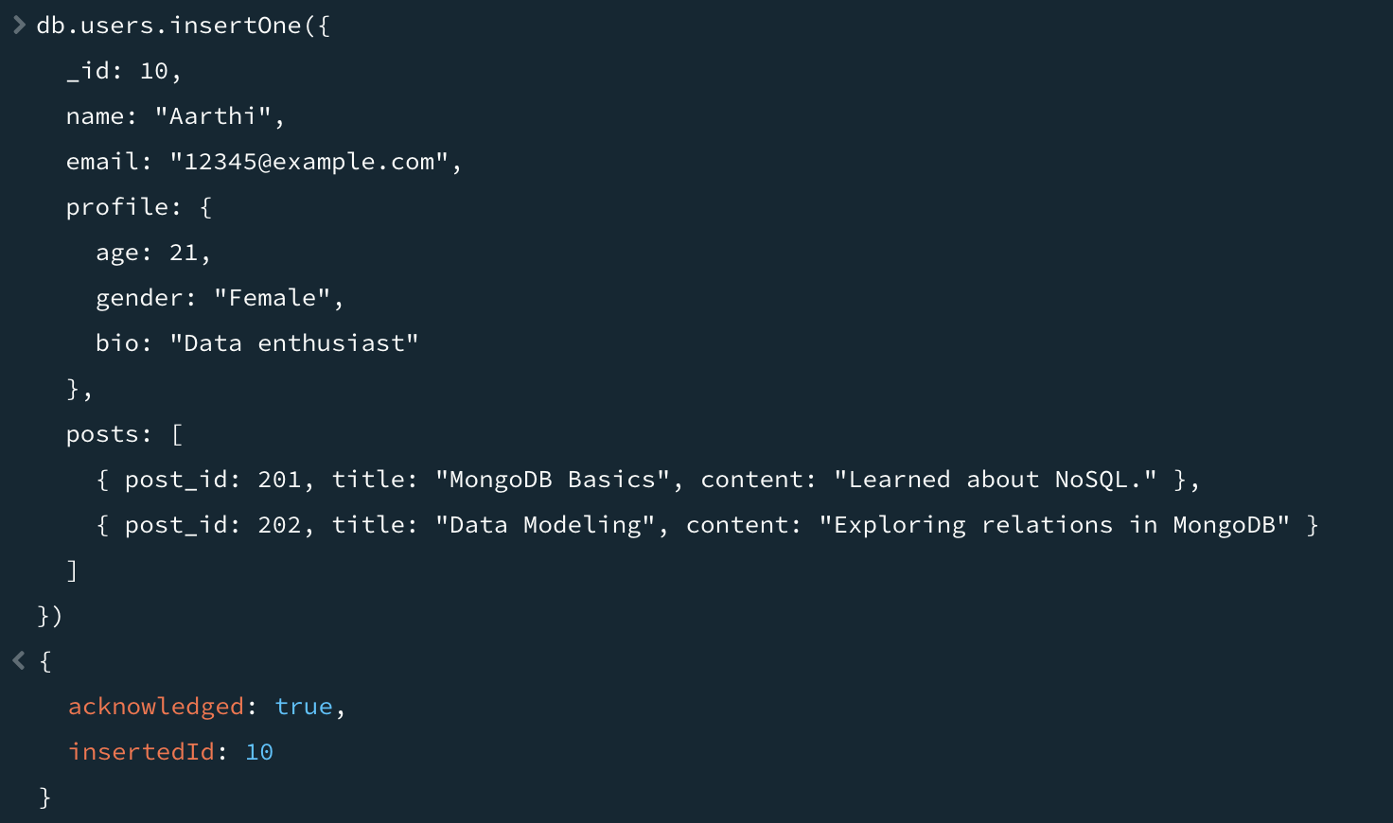

****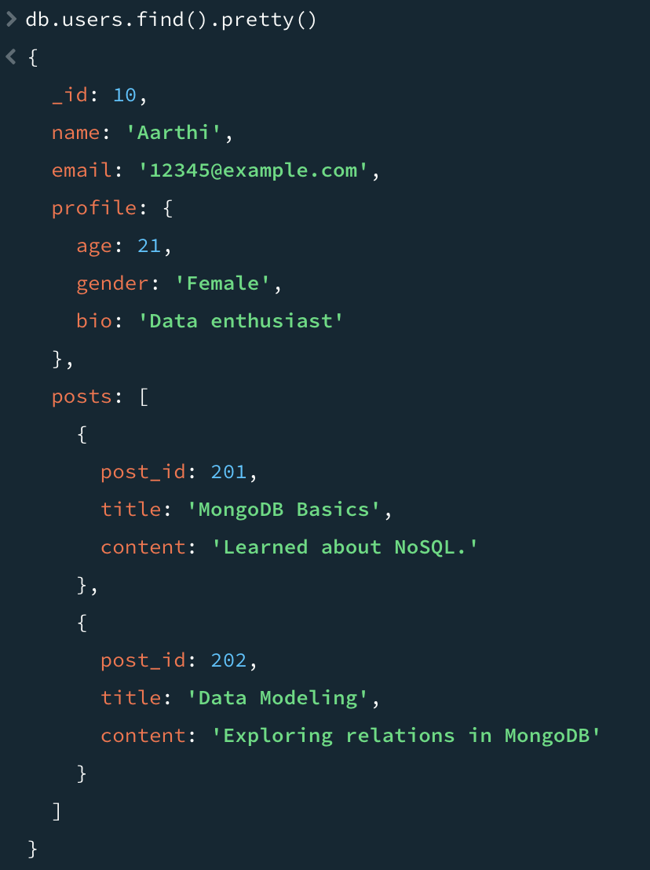****

1. **Many-to-Many (N:N):**

****

